
BAHRIA UNIVERSITY ISLAMABAD

SOFTWARE ENGINEERING (CS DEPT)
Instructions:
- Submit assignment on time and extension is not allowed.
- Complete each section and prepare a proper report for the tasks.
- Plagiarism is strictly prohibited and would result in zero marks in assignment.
- The team of two persons is allowed for an idea like given below as sample case study. Present your own ideas.
Case Study: Designing a Coffee Ordering System
You are a team lead for software development team for a client in the food industry. The client has requested the use of the Waterfall model as software development life cycle due to the project's complex and well-defined requirements. Your task is to assign roles and responsibilities of team through the stages of the Waterfall model.
The Key Features include:
- Customer Interaction
- Ordering Process
- Payment Method
- Order Delivery
- Customer Feedback
- Database Inventory Management

SE
Assignment #1


Section: BSCS-5A
Department: Computer Science
Institute: Bahria University Islamabad Campus

- You have to complete the system requirements with proper writing styles and keywords. As given sample template given in lecture notes.(2)

1. Inventory Management
1.1 Inventory Status Check:
- The system should provide a way for the POS employee to check the current inventory status, including what items are available and what needs to be restocked.
1.2 Inventory Update:
- An option should be available for updating the inventory when new stock arrives, ensuring that the system reflects the latest available items.
1.3 Consistency Maintenance:
- The system must ensure consistency between orders and inventory levels to avoid discrepancies and maintain accurate records.

2. Order Placement
2.1 Order Placement:
- The POS employee should be able to efficiently input customer orders into the system. Once entered, the system should promptly generate a bill for review.
2.2 Order Preservation:
- All orders processed by the system should be saved for future reference and record-keeping purposes.
2.3 Recent Orders Viewing:
- The system should have the capability to display a list of the most recent orders placed, allowing users to review past transactions if needed.
2.4 User-Friendly Interface:
- The system interface should be intuitive and user-friendly, facilitating easy navigation and interaction for the POS employee without requiring a significant investment.

- For the design phase, design the software system architecture and activity model for all the given tasks for this you can use lucid chart or draw.io. Submit proper designs readable with proper labelling and design. (3)

Lucid Chart UML link
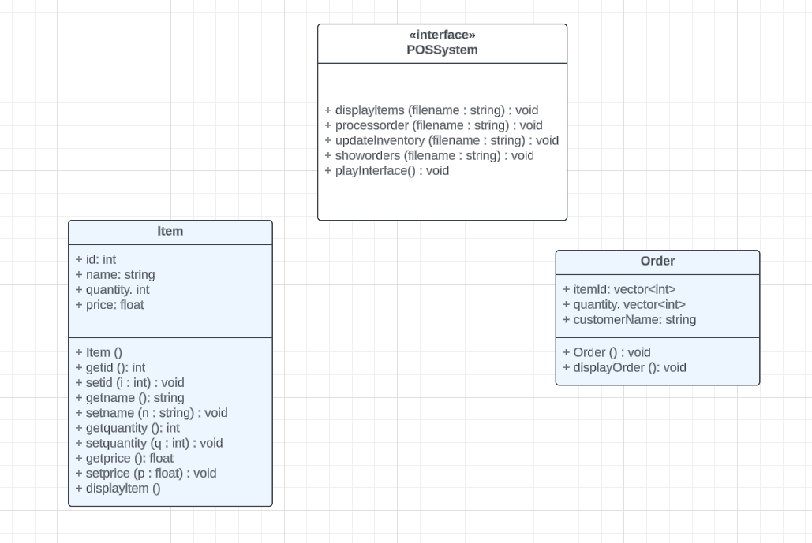

Draw.io activity flow diagram link

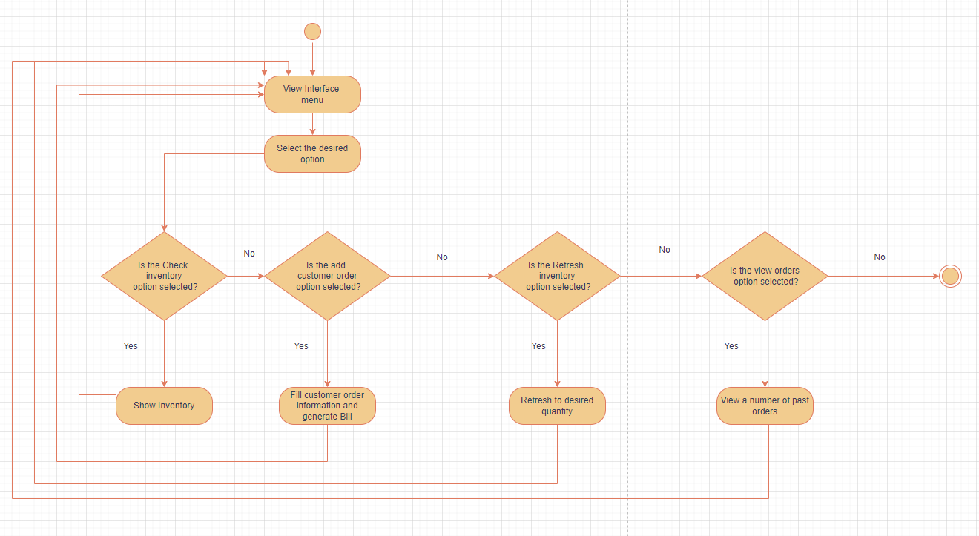
- You also have to submit the classes and major functions code snippets for the implementation phase. (3)
Prerequisite Files included for the code:
- Orders.txt
- Items.txt
Code:
#pragma comment(lib, "winmm.lib")
#include <iostream>
#include <conio.h>
#include <fstream>
#include <windows.h>
#include <vector>
#include <iomanip>
#include <string>
#include <algorithm>

using namespace std;

class Item {

public:
int id;
string name;
int quantity;
float price;
Item() {
id = 0;
name = "";
quantity = 0;
price = 0;
}
int getid() {
return id;
}
void setid(int i) {
id = i;
}
string getname() {
return name;
}
void setname(string n) {
name = n;
}
int getquantity() {
return quantity;
}
void setquantity(int q) {
quantity = q;
}
double getprice() {
return price;
}
void setprice(double p) {
price = p;
}
void displayItem() {
cout << setw(4) << id << setw(20) << name << setw(10) << quantity << setw(10) << price << endl;
}
};

class Order {
public:
vector<int> itemId;
vector<int> quantity;
string customerName;
Order() {
itemId.clear();
quantity.clear();
customerName = "";
}
void displayOrder() const {
cout << "Customer Name: " << customerName << endl;
cout << "Item ID\tQuantity" << endl;
for (size_t i = 0; i < itemId.size(); ++i) {
cout << itemId[i] << "\t" << quantity[i] << endl;
}
cout << "----------------------------------" << endl;
}
};

class POSSystem {
public:

void displayItems(string filename) {

ifstream file(filename);

if (!file.is_open()) {
cout << "Error opening file: " << filename << endl;
return;
}
vector<Item> items;
Item item;
while (file >> item.id >> item.name >> item.quantity >> item.price) {
items.push_back(item);
}

file.close();
cout << setw(4) << "ID" << setw(20) << "Name" << setw(10) << "Quantity" << setw(10) << "Price" << endl;
for (auto& item : items) {
item.displayItem();
}
}

void processOrder(string filename)
{

ifstream file(filename);
if (!file.is_open()) {
cerr << "Error opening file\n";
return;
}

// Read items from the file and store them in a vector
vector<Item> items;
Item item;
while (file >> item.id >> item.name >> item.quantity >> item.price) {
items.push_back(item);
}
file.close();

// Create a temporary order object
Order order;

// Prompt user for the name of the customer
cout << "Enter customer name: ";
getline(cin >> ws, order.customerName); // Use getline to include spaces in the name

// Prompt user to input item IDs
cout << "Enter item IDs (enter -1 to finish):" << endl;
while (true) {
int itemId;
cout << "Item ID: ";
cin >> itemId;

// Check if the user wants to finish
if (itemId == -1) {
break;
}

// Search for the item in the items vector
bool itemFound = false;
for (auto& item : items) {
if (item.id == itemId) {
itemFound = true;
// Input quantity
cout << "Enter quantity for item " << item.name << ": ";
int quantity;
cin >> quantity;

// Check if there is enough stock
if (quantity <= item.quantity) {
// Update quantity in the vector
item.quantity -= quantity;

// Add item and quantity to order
order.itemId.push_back(itemId);
order.quantity.push_back(quantity);
}
else {
cout << "Not enough stock for item " << item.name << endl;
}
break;
}
}

if (!itemFound) {
cout << "Item " << itemId << " not found" << endl;
}
}

// Display the items and quantities in the order
cout << "\n\nOrder details:" << endl;
cout << "Customer Name: " << order.customerName << endl;
cout << "Item ID\tName\tQuantity\tPrice" << endl;
float totalBill = 0;
for (size_t i = 0; i < order.itemId.size(); ++i) {
for (const auto& item : items) {
if (item.id == order.itemId[i]) {
cout << item.id << "\t" << item.name << "\t" << order.quantity[i] << "\t$" << fixed << setprecision(2) << item.price << endl;
totalBill += item.price * order.quantity[i];
break;
}
}
}

// Display total bill
cout << "Total Bill: $" << fixed << setprecision(2) << totalBill << endl;

// Write the order details to "Orders.txt" file
ofstream ordersFile("Orders.txt", ios::app);
if (!ordersFile.is_open()) {
cerr << "Error opening Orders.txt file\n";
return;
}
ordersFile << "Order details:" << endl;
ordersFile << "Customer Name: " << order.customerName << endl;
ordersFile << "Item ID\tQuantity" << endl;
for (size_t i = 0; i < order.itemId.size(); ++i) {
ordersFile << order.itemId[i] << "\t" << order.quantity[i] << endl;
}
ordersFile << "----------------------------------" << endl;
ordersFile.close();
// Write the updated quantities back to the "records.txt" file
ofstream updatedFile(filename);
if (!updatedFile.is_open()) {
cout << "Error opening records.txt file for updating quantities\n";
return;
}
for (const auto& item : items) {
updatedFile << item.id << "\t" << item.name << "\t" << item.quantity << "\t" << item.price << endl;
}
updatedFile.close();
}

void updateInventory(string filename) {

ifstream file1(filename);

if (!file1.is_open()) {
cout << "Error opening file: " << filename << endl;
return;
}
vector<Item> items;
Item item;
while (file1 >> item.id >> item.name >> item.quantity >> item.price) {
items.push_back(item);
}

file1.close();

int itemId, newQuantity;
cout << "Enter the item ID to update its inventory: ";
cin >> itemId;

// Find the item in the vector
for (auto& item : items) {
if (item.id == itemId) {
cout << "Enter the new quantity: ";
cin >> newQuantity;
item.quantity = max(0, newQuantity); // Ensure the quantity is not less than 0
break;
}
}

// Rewrite the items file with the updated information
ofstream file(filename);
if (!file.is_open()) {
cerr << "Error opening items file\n";
return;
}
for (const auto& item : items) {
file << item.id << "\t" << item.name << "\t" << item.quantity << "\t" << item.price << endl;
}
file.close();
}

void showOrders(string filename)
{
int numOrders;
cout << "Enter the number of orders to show: ";
cin >> numOrders;

ifstream file(filename);
if (!file.is_open()) {
cerr << "Error opening Orders.txt file\n";
return;
}

vector<Order> orders;
string line;
Order order;

// Read orders from the file
while (getline(file, line)) {
if (line == "----------------------------------") {
orders.push_back(order);
order = Order();
}
else if (line.find("Customer Name: ") != string::npos) {
order.customerName = line.substr(line.find(":") + 2); // Extract customer name
}
else if (line.find("\t") != string::npos) {
size_t tabPos = line.find("\t");
if (tabPos != string::npos && tabPos < line.size() - 1) {
try {
int itemId = stoi(line.substr(0, tabPos)); // Extract item ID
int quantity = stoi(line.substr(tabPos + 1)); // Extract quantity
order.itemId.push_back(itemId);
order.quantity.push_back(quantity);
}
catch (const exception& e) {

}
}
}
}
file.close();

// Validate the number of orders to show
if (numOrders <= 0 || numOrders > static_cast<int>(orders.size())) {
cout << "Invalid number of orders to show" << endl;
return;
}

// Display the requested number of orders from the end
cout << "Showing " << numOrders << " orders from the end:" << endl;
for (int i = static_cast<int>(orders.size()) - numOrders; i < static_cast<int>(orders.size()); ++i) {
orders[i].displayOrder();
}
}

void playInterface()
{
HANDLE h = GetStdHandle(STD_OUTPUT_HANDLE);
short enter = '1';
short arrowKey = '1';
short enter1 = 192;
short enter2 = 7;
short enter3 = 7;
short enter4 = 7;
short enter5 = 7;
string coutArray[5];
coutArray[0].erase();
coutArray[0] += "\n\n\t\t\t\t\tCheck Inventory";
coutArray[1].erase();
coutArray[1] += "\n\n\t\t\t\t\tAdd Customer Order";
coutArray[2].erase();
coutArray[2] += "\n\n\t\t\t\t\tRefresh Inventory";
coutArray[3].erase();
coutArray[3] += "\n\n\t\t\t\t\tView Orders";
coutArray[4].erase();
coutArray[4] += "\n\n\t\t\t\t\tExit\n\n\n\n\n\n\n";
short coutArrayIndex = 0;
system("CLS");

cout << "\n\n\n POSSystem\n\n\n\n\n\n\n\t\t\t";
SetConsoleTextAttribute(h, enter1);
cout << coutArray[0];
SetConsoleTextAttribute(h, enter2);
cout << coutArray[1];
SetConsoleTextAttribute(h, enter3);
cout << coutArray[2];
SetConsoleTextAttribute(h, enter4);
cout << coutArray[3];
SetConsoleTextAttribute(h, enter5);
cout << coutArray[4];
SetConsoleTextAttribute(h, 7);
cout << endl;

while (enter != 13)
{
enter = _getch();
if (enter == 13)
{
break;
}
//Enter = 13 and \n = 10
if (enter == 224)
{
arrowKey = _getch();
if (arrowKey == 72) //up
{
if (coutArrayIndex == 0)
{
coutArrayIndex = 4;
}
else
{
coutArrayIndex--;
}
}
else if (arrowKey == 80) //down
{
coutArrayIndex = ++coutArrayIndex % 5;
}
if (coutArrayIndex == 0)
{
enter1 = 192;
enter2 = 7;
enter3 = 7;
enter4 = 7;
enter5 = 7;
}
else if (coutArrayIndex == 1)
{
enter1 = 7;
enter2 = 192;
enter3 = 7;
enter4 = 7;
enter5 = 7;
}
else if (coutArrayIndex == 2)
{
enter1 = 7;
enter2 = 7;
enter3 = 192;
enter4 = 7;
enter5 = 7;
}
else if (coutArrayIndex == 3)
{
enter1 = 7;
enter2 = 7;
enter3 = 7;
enter4 = 192;
enter5 = 7;
}
else if (coutArrayIndex == 4)
{
enter1 = 7;
enter2 = 7;
enter3 = 7;
enter4 = 7;
enter5 = 192;
}
system("CLS");
cout << "\n\n\n POSSystem\n\n\n\n\n\n\n\t\t\t";
SetConsoleTextAttribute(h, enter1);
cout << coutArray[0];
SetConsoleTextAttribute(h, enter2);
cout << coutArray[1];
SetConsoleTextAttribute(h, enter3);
cout << coutArray[2];
SetConsoleTextAttribute(h, enter4);
cout << coutArray[3];
SetConsoleTextAttribute(h, enter5);
cout << coutArray[4];
SetConsoleTextAttribute(h, 7);
cout << endl;
}
else
{
continue;
}
}
if (coutArrayIndex == 0) //Check Inventory
{
system("CLS");
cout << "\n\n\n Inventory\n\n\n\n\n\n\n";
displayItems("Items.txt");
_getch();

}
else if (coutArrayIndex == 1) //Add Customer Order
{
system("CLS");
processOrder("Items.txt");
_getch();
}
else if (coutArrayIndex == 2) //Refresh Inventory
{
system("CLS");
char choice = 'y';
while (choice == 'y' || choice == 'Y')
{
updateInventory("Items.txt");
cout << "Update another item? Press anything except \'y\' and \'Y\' for no: ";
cin >> choice;
}
_getch();
}
else if (coutArrayIndex == 3) //View Orders
{
system("CLS");
showOrders("Orders.txt");
_getch();
}
else if (coutArrayIndex == 4) //Exit
{
cout << "\n\n\n\n\n\n\n";
exit(0);
}
playInterface();
return;
}
};
int main()
{
POSSystem a;
a.playInterface();

_getch();
return 0;
}

- For the verification phase, mention one of your friend as a system tester and get the feedback on all the key features and write down those comments in proper format in this report. (2)
Testing Prerequisites:
Inventory Management
1.Inventory Status Check (Function: displayItems):
Description: The system provides a way for the POS employee to check the current inventory status, displaying available items and those that need restocking.
Input: Filename of the inventory file.
Output: Displays a formatted list of items with their IDs, names, quantities, and prices.
2. Inventory Update (Function: updateInventory):
Description: Allows the POS employee to update the inventory when new stock arrives, ensuring that the system reflects the latest available items.
Input: Filename of the inventory file.
Output: Updates the inventory file with the new quantity of the specified item.
3.Consistency Maintenance:
Description: The system maintains consistency between orders and inventory levels to avoid discrepancies and maintain accurate records.
Order Placement
1.Order Placement (Function: processOrder):
Description: Enables the POS employee to efficiently input customer orders into the system, generating a bill promptly for review.
Input: Filename of the inventory file.
Output: Displays order details including customer name, item IDs, quantities, and total bill. Updates the orders file and inventory file accordingly.
2.Order Preservation:
Description: All orders processed by the system are saved for future reference and record-keeping purposes.
3.Recent Orders Viewing (Function: showOrders):
Description: Provides the capability to display a list of the most recent orders placed, allowing users to review past transactions if needed.
Input: Filename of the orders file.
Output: Displays the requested number of recent orders with customer names, item IDs, and quantities.
User Interface
1.User-Friendly Interface (Function: playInterface):
Description: The system interface is intuitive and user-friendly, facilitating easy navigation and interaction for the POS employee without requiring a significant investment.
Input: Keyboard inputs from the user.
Output: Displays menu options and responds to user inputs accordingly, providing a seamless user experience.

Testing Strategy
Unit Testing:
Check Inventory():
There was an issue in the checking of inventory that when we were displaying inventory more then one time, the same item was displaying repeatedly. As a solution to this we created a temporary variable in the function so that it can read every time inside the function.
Add Customer Order():
There was no issue in this unit.
RefreshInventory():
There was an issue in this unit that when we update the inventory in file, there was issue in the formatting of the file. As a solution to this, we made changes to the variables and rewrite the whole vector in the file.
ViewOrders():
There was no issue in this unit.
Exit():
This unit was working properly.

Integration Testing: Our one member was working on logical part of the code and another member was working on interface. When we integrated interface with logical part it was not working properly. As a solution to this, we modified the code a little bit so that the logical part should integrate with interface.
System Testing: Our system was not very large so there was no issue in system testing. We performed end-to-end testing of common user scenarios to ensure the system meets the requirements outlined in the documentation.
Acceptance Testing: At the end, both of our members sit face to face to test the whole system and we both agreed on the overall acceptance of the system without any error. We showed the whole system to the stakeholders and they approved.

